Experiment Manager Plug-in Documentation

Version 1.0.0.1 by Sven Gijsen

Introduction
With the Experiment Manager Plug-in it is possible to present different kind of stimuli. It can make use of an Experiment file (*.exml) that defines all the stimuli setup and configuration; see the EXML-File definition. In the StimulGL/scripts folder you may find an script file “ExperimentManager.qs” which shows how an Experiment Manger Plug-in can be used together with an experiment file. There are some example Experiment files located in the StimulGL/Experiments folder which you can use as template.

EXML-File definition
The experiment file is an XML type of file which is used by the Experiment Manger to configure the stimuli it’s presents. You can manually edit this document in StimulGL or another text/code editor. The first lines consist out of a file header:

<?xml version='1.0' encoding='UTF-8'?>
<!DOCTYPE EXML>
<EXML version="1.0.0.0">

The header holds the XML and EXML version, there’s no reason to change this.
You may also find text between the <!-- and --> tag, these are used for comments and the text section between these tags is not parsed by the Experiment Manager.

The <defines> section has an <experiment> section where the name of the experiment can be defined and also whether the experiment should be executed in debugmode or not. This mode can be helpful during the setup and debugging of the experiment because it gives some additional information, but because it can slow down the stimuli you should never enable it when you’re actually running the real experiment.

In the <declarations> section all objects are declared that are used for the experiment.

Inside the <connections> section declared objects can be connected to each other (internally it’s using the Qt signal/slot mechanism for the connection).

Declared objects are initialized before the experiment starts within the <initializations> section.

When the experiment starts the section within the <actions> tag is executed. In case of a triggered block design you can specify this within a <blocks > section, see the Block design experiment.

Block design experiment

<block_number>:
There can be multiple blocks defined within one experiment, the block number defines how the blocks are processed.
<nr_of_trials>:
Within a block an trial amount defines how many times the block is processed.
<nr_of_internal_triggers>
The number of triggers per trial.
<nr_of_external_triggers>
If >1 then it waits for n triggers before incrementing the internal trigger counter!

Parameter | Possible values | Definition
RetinoPattern | "PolarAngle" (default)  "Eccentricity"  "MovingBar"  "MovingDots"  "Fixation" | See below

OutputTriggerFrame : true||false
OutputFrameFormat png||dat
OutputFrameType Frame (default) || Mask
explanation?
DiscreteTriggerSteps: true||false false
RandomizeTriggerSteps true||false false
EmptyTriggerSteps int(0 -- depends on nr of triggers per block) 0
DisplayRefreshRate int(0 .. depends on max rate) 0
0 draws as fast as possible with a wait for VSync if enabled. Rate is in Hertz

All parameters keep buffer their last set value during the experiment.

first frame takes actually 3 frames therefore its advisable to ignore the first blocktriggertrial?

CTRL+A means abort!
NON RANDOM
Toont eerst index 0 die afhankelijk van de richting is!
1 0 RetinoMap_glwidget::paintObject
EmptyRandomList = 0,10,8,2,3,6,5,1,11,4,9,7 3034.9
welke stappen (niet indexen!) weg zijn...

dus eerst bij bv. EmptyTriggerSteps = 2 --> wedge met index 0 en 10 weg

RANDOM

EmptyRandomList = 2,1,0,7,3,11,6,4,9,10,8,5
StimRandomList = 9,3,0,2,6,5,10,11,7,8,1,4

Toont eerst index 9 die afhankelijk van richting is!
dus eerst bij bv. EmptyTriggerSteps = 2 --> wedge 2 en 1 weg

Color format:
Sets the RGB value, which may be in one of these formats:
• #RGB (each of R, G, and B is a single hex digit)
• #RRGGBB
• #RRRGGGBBB
• #RRRRGGGGBBBB
A name from the list of colors defined in the list of SVG color keyword names provided by the World Wide Web Consortium; for example, "steelblue" or "gainsboro". These color names work on all platforms.
RetinoPattern = "Fixation"


A

Parameter | Possible values | Definition
ShowFixPoint | "true" or "false" (default = "true") | Defines if the fixation point in the center of the screen is visible, see A
FixationSize | Integer value (default = 8) | Defines the diameter of the fixation point in number of pixels
FixationColor | HEX string representing a RGB color, see color format (default = #FF0000) | Use this parameter to change the color of the fixation dot.
BackGroundColor | HEX string representing a RGB color, see color format (default = #575757) | Use this parameter to change the color of the background.

RetinoPattern = "PolarAngle"

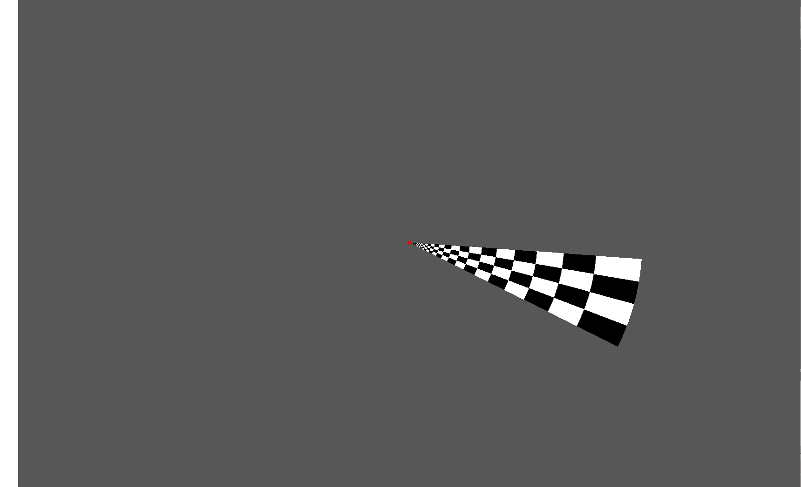

A
B

Parameter | Possible values | Definition
ShowFixPoint | "true" or "false" (default = "true") | Defines if the fixation point in the center of the screen is visible
GapDiameter | Integer value (default = 20.0) | The diameter (pixels) of the gap (no stimulus) centered at the fixation point
CycleTriggerAmount | Integer value (default = 1) | The duration of a full wedge cycle (360 degrees) in amount of triggers
PolarWedgeSpan | Float value (default = 22.5) | The total span angle of the wedge in degrees(see A)
PolarCheckAmount | Integer value (default = 4) | The number of checks(see A) of the wedge
PolarRingAmount | Integer value (default = 20) | The number of rings(see B) of the wedge
StimulusWidthSpan | Float value (default = Screen.height, to make it square) | The size of the stimulus (=2*B, see above)
StimulusHeightSpan | Float value (default = Screen.height) | See "stimulus pixel no x"
FlickrFrequency | Float value (default = 5) | The frequency of the flickr cycle(when the checks change color)
PolarRotationDirection | "1" or "-1" (default = 1) | "1" = Clockwise  "-1" = Counterclockwise
InternalTriggerDuration | Float value (default = 2000.0) | The expected trigger period time duration, this defines how fast the wedge rotates
CorticalMagnitudeFactor | Float value (default = 0.2) | See below
FixationSize | Integer value (default = 8) | Defines the diameter of the fixation point in number of pixels
DisableCortMagFac | "true" or "false" (default = "false") | When enabled the single ring diameters (see A below picture) is the same for all rings. The ring diameter then is always the blabla
FixationColor | HEX string representing a RGB color, see color format (default = #FF0000) | Use this parameter to change the color of the fixation dot.
CheckerColor1 | HEX string representing a RGB color, see color format (default = #FFFFFF) | Use this parameter to change the color of the first checker.
CheckerColor2 | HEX string representing a RGB color, see color format (default = #000000) | Use this parameter to change the color of the second checker.
BackGroundColor | HEX string representing a RGB color, see color format (default = #575757) | Use this parameter to change the color of the background.

CorticalMagnitudeFactor:
This defines how the rings are distributed from the outer wedge ring towards the center. See below picture. E.g. CorticalMagnitudeFactor = 0.2 ==>
A = 0.2 * B
A' = 0.2 * B'
...
The most inner ring is automatically extended till the border of the defined gap diameter

Important! If (CorticalMagnitudeFactor == 0.0) then the rings are all equally divided over the wedge (B).

The start angle of the wedge rotation cycle is at 0 degrees (at the X axis pointed to the right, with the right wedge border aligned over the X axis), see below (the wedge is at 0 degrees):

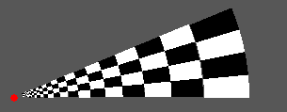
B
B'
A
A'
Different indexes (with 12 steps)

PolarRotationDirection = 1, see below

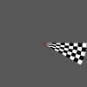 | 0 | 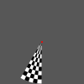 | 3 | 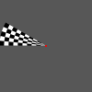 | 6 | 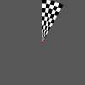 | 9
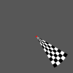 | 1 | 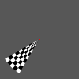 | 4 | 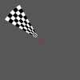 | 7 | 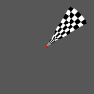 | 10
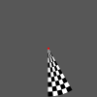 | 2 | 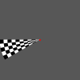 | 5 | 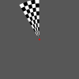 | 8 | 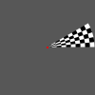 | 11

PolarRotationDirection = -1, see below

 | 0 |  | 3 |  | 6 |  | 9
 | 1 |  | 4 |  | 7 |  | 10
 | 2 |  | 5 |  | 8 |  | 11

RetinoPattern = "Eccentricity"

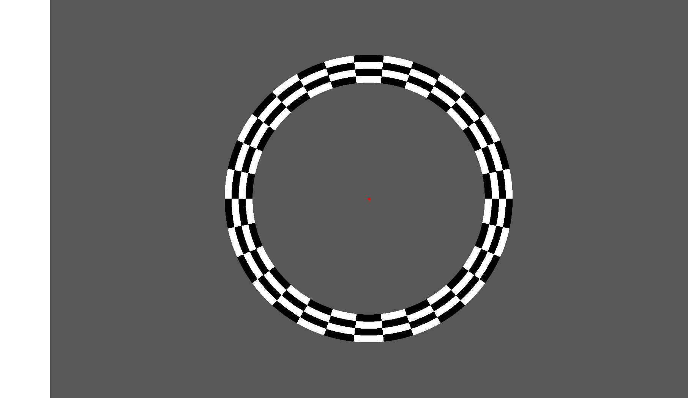

A

B
A

Parameter | Possible values | Definition
ShowFixPoint | "true" or "false" (default = "true") | Defines if the fixation point in the center of the screen is visible
GapDiameter | Integer value (default = 20.0) | The diameter (pixels) of the gap (no stimulus) centered at the fixation point
CycleTriggerAmount | Integer value (default = 1) | The duration of a full cycle (increased/decreased diameter) in amount of triggers, the minimal diameter is the gap diameter
EccentricityCheckAmount | Integer value (default = 20) | The number of checks(see A) of one ring
EccentricityRingAmount | Integer value (default = 4) | The number of rings(see B)
StimulusWidthSpan | Float value (default = Screen.height, to make it square) | The size of the stimulus (=2*B, see above)
StimulusHeightSpan | Float value (default = Screen.height) | See "stimulus pixel no x"
FlickrFrequency | Float value (default = 5) | The frequency of the flickr cycle(when the checks change color)
EccentricityDirection | "1" or "-1" (default = 1) | "1" = Increased ring diameter  "-1" = Decreased ring diameter
InternalTriggerDuration | Float value (default = 2000.0) | The expected trigger period time duration, this defines how fast the ring increases/decreases
CorticalMagnitudeFactor | Float value (default = 0.2) | See below
FixationSize | Integer value (default = 8) | Defines the diameter of the fixation point in number of pixels
DisableCortMagFac | "true" or "false" (default = "false") | When enabled the total ring diameter (see A below picture) remains the same independent off the eccentricity. The total ring diameter then is always the CorticalMagnitudeFactor times the maximum radius (B)
FixationColor | HEX string representing a RGB color, see color format (default = #FF0000) | Use this parameter to change the color of the fixation dot.
CheckerColor1 | HEX string representing a RGB color, see color format (default = #FFFFFF) | Use this parameter to change the color of the first checker.
CheckerColor2 | HEX string representing a RGB color, see color format (default = #000000) | Use this parameter to change the color of the second checker.
BackGroundColor | HEX string representing a RGB color, see color format (default = #575757) | Use this parameter to change the color of the background.

CorticalMagnitudeFactor(see below picture):
This defines how the total width (see B) of all the visible rings summarized. This width is dependant of the ring diameter thus the increased/decreased value at that moment. The minimal visible ring diameter is equal to the gap diameter.

E.g. CorticalMagnitudeFactor = 0.2 ==>
A = 0.2 * B
A' = 0.2 * B'
...
All individual ring widths are equal.

A

A
Gap
B

Different indexes (with 12 steps)

EccentricityDirection = 1, see below

 | 0 | 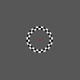 | 3 | 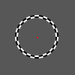 | 6 | 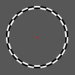 | 9
 | 1 | 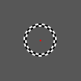 | 4 | 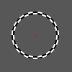 | 7 | 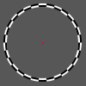 | 10
 | 2 | 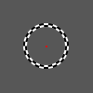 | 5 | 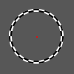 | 8 | 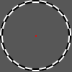 | 11

EccentricityDirection = -1, see below

 | 0 |  | 3 |  | 6 |  | 9
 | 1 |  | 4 |  | 7 |  | 10
 | 2 |  | 5 |  | 8 |  | 11

RetinoPattern = "MovingBar"

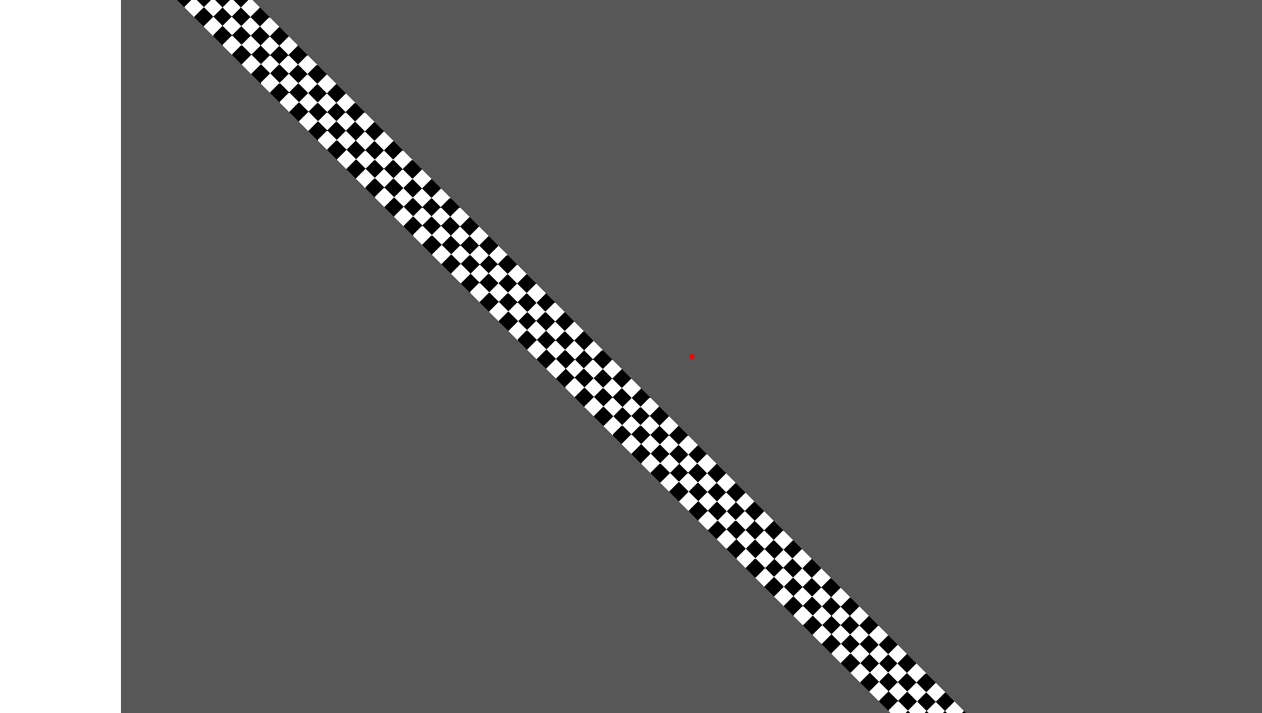

A

A
B
C

Parameter | Possible values | Definition
ShowFixPoint | "true" or "false" (default = "true") | Defines if the fixation point in the center of the screen is visible
CycleTriggerAmount | Integer value (default = 1) | The duration of a full bar movement in amount of triggers
MovingBarHeightCheckAmount | Integer value (default = 4) | The maximum number of checks (see B) of the bar in the width direction
StimulusWidthSpan | Float value (default = Screen.height, to make it square) | The size of the stimulus (width)
StimulusHeightSpan | Float value (default = Screen.height) | The size of the stimulus (height)
FlickrFrequency | Float value (default = 5) | The frequency of the flickr cycle(when the checks change color)
MovingBarAngle | Float value (default = 45.0) | The angle of the bar, 0 degrees is along the X axis. A positive value turns counterclockwise
MovingBarCoverage | Float value (default = 0.5) | The stimulus area coverage of a full bar cycle movement(see c). See below for a detailed description.
MovingBarDirection | "1" or "-1" (default = 1) | "1" = Up to Down  "-1" = Down to Up
InternalTriggerDuration | Float value (default = 2000.0) | The expected trigger period time duration, this defines how fast the bar moves
FixationSize | Integer value (default = 8) | Defines the diameter of the fixation point in number of pixels
MovingBarIncludeOppositeDirection  (Disabled option!) | "true" or "false" (default = "false") | Determines whether the movement of a cycle should include the movement to the original position
movingBarWidth | Float value (default = 10.0) | E.g. if the total moving bar movement is 640 pixel then the bar width (see b) is 640/10.0 = 64 pixels.
FixationColor | HEX string representing a RGB color, see color format (default = #FF0000) | Use this parameter to change the color of the fixation dot.
CheckerColor1 | HEX string representing a RGB color, see color format (default = #FFFFFF) | Use this parameter to change the color of the first checker.
CheckerColor2 | HEX string representing a RGB color, see color format (default = #000000) | Use this parameter to change the color of the second checker.
BackGroundColor | HEX string representing a RGB color, see color format (default = #575757) | Use this parameter to change the color of the background.

MovingBarCoverage (See below picture):
We see a stimulus area (smaller than the screen area, see red rectangle and the diagonal B). The bar is at the first initial position and moves along the direction of the yellow arrow(A) until it reaches the orange border above the fixation dot. The stimulus screen coverage is within the orange borders. The coverage is defined as:
A = MovingBarCoverage * B

the checkers are squared!
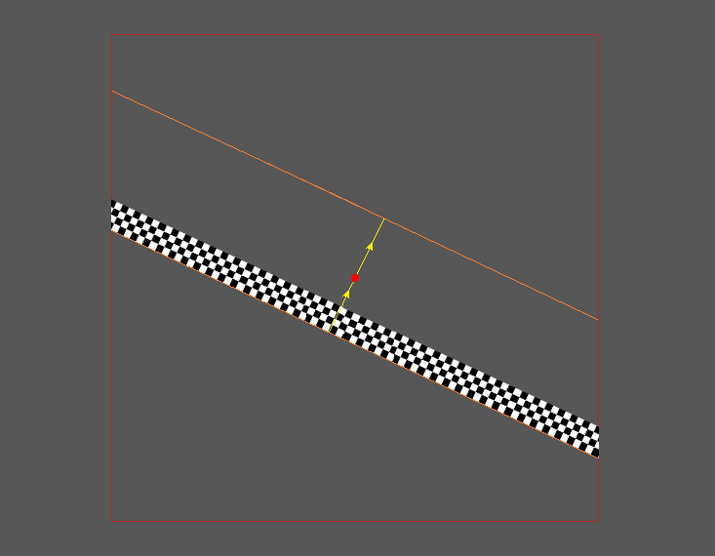
B
A
MovingBarDirection = 1, see below (MovingBarAngle = 30)

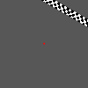 | 0 | 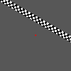 | 3 | 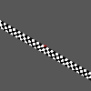 | 6 | 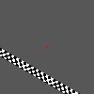 | 9
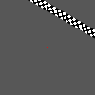 | 1 | 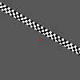 | 4 | 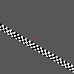 | 7 | 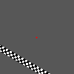 | 10
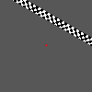 | 2 | 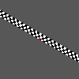 | 5 | 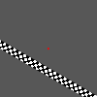 | 8 | 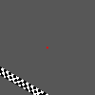 | 11

MovingBarDirection = -1, see below (MovingBarAngle = 30)

 | 0 |  | 3 | 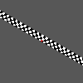 | 6 |  | 9
 | 1 |  | 4 |  | 7 | 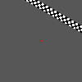 | 10
 | 2 |  | 5 |  | 8 |  | 11

RetinoPattern = "MovingDots"

Parameter | Possible values | Definition
FixationSize | Integer value (default = 8) | Defines the diameter of the fixation point in number of pixels
ShowFixPoint | "true" or "false" (default = "true") | Defines if the fixation point in the center of the screen is visible
GapDiameter | Integer value (default = 20.0) | The diameter (pixels) of the gap (no stimulus) centered at the fixation point
CycleTriggerAmount | Integer value (default = 1) | The duration of a full cycle (increased/decreased diameter) in amount of triggers, the minimal diameter is the gap diameter
StimulusWidthSpan | Float value (default = Screen.height, to make it square) | The size of the stimulus (=2*B, see above)
StimulusHeightSpan | Float value (default = Screen.height) | See "stimulus pixel no x"
InternalTriggerDuration | Float value (default = 2000.0) | The expected trigger period time duration, this defines how fast the ring increases/decreases
MovingDotsMoveSpeed | Float value (default =1)
MovingDotsNrOfDots | Integer value (default =1000)
MovingDotsDotSize | Integer value (default =12)
MovingDotsHemifield | "Left" or "Right" or "Both" (default = "Both")
MovingDotsPixelFromCenter | Integer value (default =100)
MovingDotsStationairy | "true" or "false" (default = "false")
MovingDotsRetinalPosition | Not implemented yet! | Not implemented yet!
MovingDotsFieldWidth | Integer value (above StimulusWidthSpan)
MovingDotsFieldHeigth | Integer value (above StimulusHeightSpan)
FixationColor | HEX string representing a RGB color, see color format (default = #FF0000) | Use this parameter to change the color of the fixation dot.
CheckerColor1 | HEX string representing a RGB color, see color format (default = #FFFFFF) | Use this parameter to change the color of the first checker.
CheckerColor2 | HEX string representing a RGB color, see color format (default = #000000) | Use this parameter to change the color of the second checker.
BackGroundColor | HEX string representing a RGB color, see color format (default = #575757) | Use this parameter to change the color of the background.

